NAME : Ibrar Babar

Roll no : 19P-0104

BS(Computer Science)

DLD Lab: Section (2B2)

Sir Yousaf

**Task # 1**

**(2 : 4 DECODER)**

**TRUTH TABLE:**

|  |  |  |  |  |  |
| --- | --- | --- | --- | --- | --- |
| **A** | **B** | **D0** | **D1** | **D2** | **D3** |
| **0** | **0** | **1** | **0** | **0** | **0** |
| **0** | **1** | **0** | **1** | **0** | **0** |
| **1** | **0** | **0** | **0** | **1** | **0** |
| **1** | **1** | **0** | **0** | **0** | **1** |

**Circuit Diagram:**

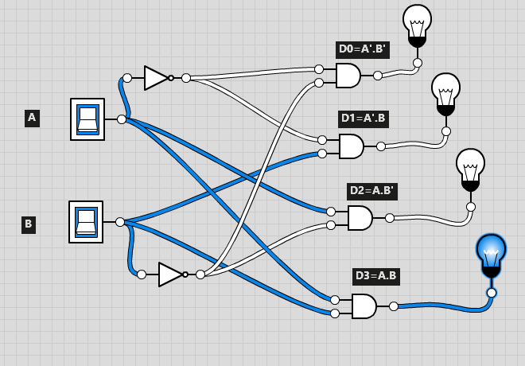

**(3:8 DECODER)**

**TRUTH TABLE:**

|  |  |  |  |  |  |  |  |  |  |  |
| --- | --- | --- | --- | --- | --- | --- | --- | --- | --- | --- |
| **A** | **B** | **C** | **D0** | **D1** | **D2** | **D3** | **D4** | **D5** | **D6** | **D7** |
| **0** | **0** | **0** | **1** | **0** | **0** | **0** | **0** | **0** | **0** | **0** |
| **0** | **0** | **1** | **0** | **1** | **0** | **0** | **0** | **0** | **0** | **0** |
| **0** | **1** | **0** | **0** | **0** | **1** | **0** | **0** | **0** | **0** | **0** |
| **0** | **1** | **1** | **0** | **0** | **0** | **1** | **0** | **0** | **0** | **0** |
| **1** | **0** | **0** | **0** | **0** | **0** | **0** | **1** | **0** | **0** | **0** |
| **1** | **0** | **1** | **0** | **0** | **0** | **0** | **0** | **1** | **0** | **0** |
| **1** | **1** | **0** | **0** | **0** | **0** | **0** | **0** | **0** | **1** | **0** |
| **1** | **1** | **1** | **0** | **0** | **0** | **0** | **0** | **0** | **0** | **1** |

**Circuit Diagram:**

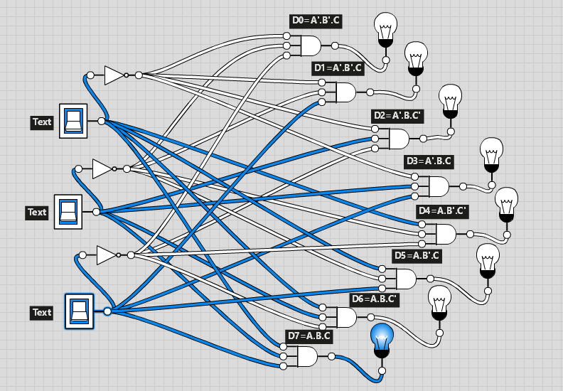

**========================================================**

**Task # 3**

**(4:2 Encoder)**

**TRUTH TABLE:**

|  |  |  |  |  |  |  |
| --- | --- | --- | --- | --- | --- | --- |
| **D0** | **D1** | **D2** | **D3** | **A** | **B** | **V** |
| **0** | **0** | **0** | **0** | **X** | **X** | **0** |
| **1** | **0** | **0** | **0** | **0** | **0** | **1** |
| **X** | **1** | **0** | **0** | **0** | **1** | **1** |
| **X** | **X** | **1** | **0** | **1** | **0** | **1** |
| **X** | **X** | **X** | **1** | **1** | **1** | **1** |

**K-map:**

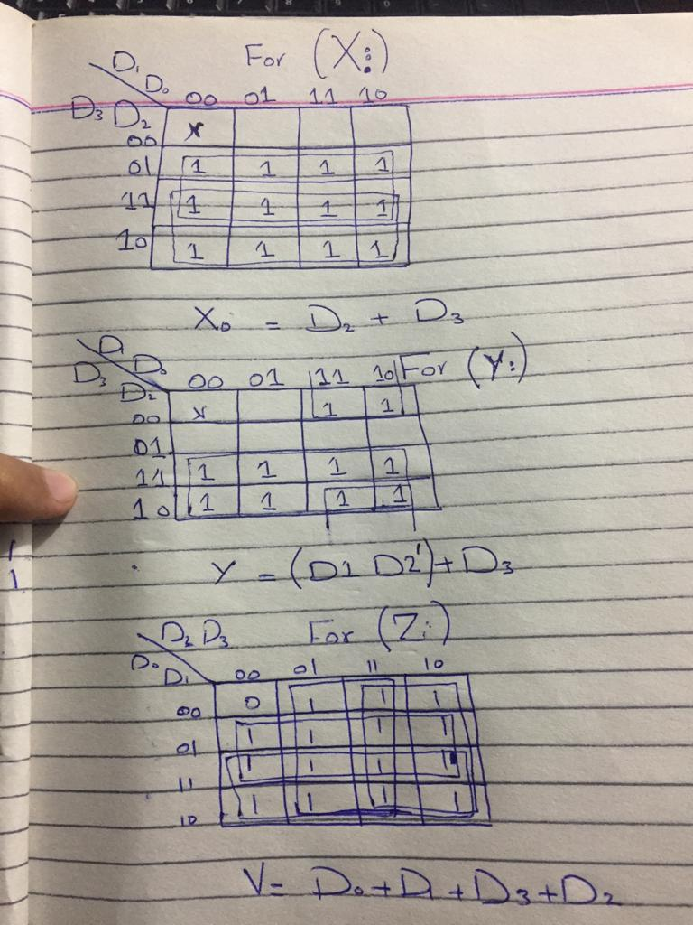

**Circuit Diagram:**

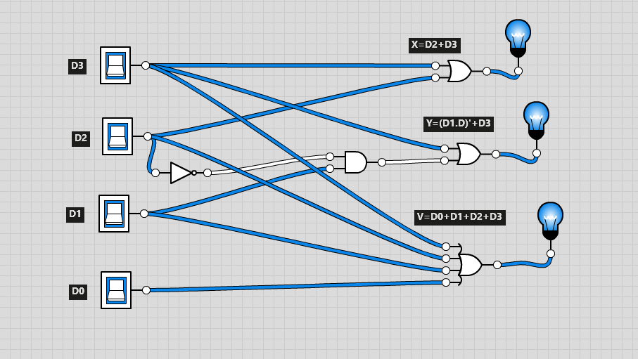

**Task # 4:**

**(8:3 ENCODER)**

**TRUTH TABLE:**

|  |  |  |  |  |  |  |  |  |  |  |  |
| --- | --- | --- | --- | --- | --- | --- | --- | --- | --- | --- | --- |
| **D0** | **D1** | **D2** | **D3** | **D4** | **D5** | **D6** | **D7** | **A** | **B** | **C** | **V** |
| **0** | **0** | **0** | **0** | **0** | **0** | **0** | **0** | **X** | **X** | **X** | **0** |
| **1** | **0** | **0** | **0** | **0** | **0** | **0** | **0** | **0** | **0** | **0** | **1** |
| **X** | **1** | **0** | **0** | **0** | **0** | **0** | **0** | **0** | **0** | **1** | **1** |
| **X** | **X** | **1** | **0** | **0** | **0** | **0** | **0** | **0** | **1** | **0** | **1** |
| **X** | **X** | **X** | **1** | **0** | **0** | **0** | **0** | **0** | **1** | **1** | **1** |
| **X** | **X** | **X** | **X** | **1** | **0** | **0** | **0** | **1** | **0** | **0** | **1** |
| **X** | **X** | **X** | **X** | **X** | **1** | **0** | **0** | **1** | **0** | **1** | **1** |
| **X** | **X** | **X** | **X** | **X** | **X** | **1** | **0** | **1** | **1** | **0** | **1** |
| **X** | **X** | **X** | **X** | **X** | **X** | **X** | **1** | **1** | **1** | **1** | **1** |

**==========================================================**